Egyptian Prophecy

Before you can really understand Egyptian Prophecy, you need to understand this fact: **The Great Pyramid of Egypt is the Biblical Tower of Babel**

|  |  |
| --- | --- |
| http://www.truthseekeratroswell.com/images/051010_2k.jpg?crc=3771622436 | Not only is the construction of the pyramids a mystery, but their age is as well. Most Egyptologists refer to a period of time about 2600 BC during the reign of the 4th Dynasty Pharaoh Khufu. The problem with that however is the fact that nothing has ever been discovered inside the great pyramid, other than an empty lidless box (coffer) to indicate a Pharaoh was ever buried there, as no artifacts for the afterlife were present when the Arabs first entered the pyramid about 820AD. The only reference to Khufu found was a 3”statue (left), located miles from the pyramids which is today on display in the Cairo museum. (Not much of a legacy for a Pharaoh supposedly buried in a pyramid built for him.)  <http://www.truthseekeratroswell.com/building.html> |

The above is true other than the 2600 BC.

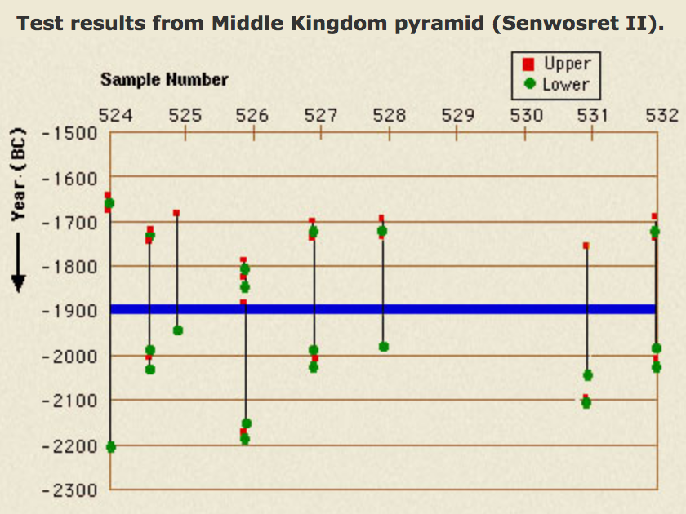

The insert is an example of Carbon-14 dating for the Middle Kingdom. This is like hitting a large barn with a shotgun. Although it seems accurate according the Egyptologist dating in blue, it does not solve for dating accuracy. The further back in time, accuracy become less and less accurate. The above is more likely the kingdom of building Pyramids to bury the dead Pharaohs, which is probably the reason the Lord, *confounded the language of all the earth*. ([Gen. 11:9](https://www.lds.org/scriptures/ot/gen/11.9?lang=eng#8)). Earth means the Kingdom of God

Carbon-14 Dating

Before a religious discussion can be studied, there needs some simple logic about physics. Even though scientists use modern accelerators, we should understand that any method is like an atomic clock. It measures the motion of light. Modern physics assumes that light travels at a constant velocity in a vacuum everywhere in the universe. Because glass is not a vacuum, light slows down until it gets to the other side. Then it picks up speed appropriate for the air it travels through. The argument is that glass is denser with matter. This is true for reflection and refraction off and around atomic particles, but most of the light travels a strait line otherwise we could never photograph and image through a pain of glass. If a photon travels slower, but in a straight line, what is causing the slower speed if a specific photon does not hit anything or curve around a particle by going to close? A simple answer is that the magnetic density inside the glass is greater than outside. This is not because of the added density of the individual atoms. Atoms occupy an immensity of space allowing photons to pass through. Magnetic density will govern the speed of light and not the atoms unless the atomic structure has not path, but who will say this?

Another point is that light is not the oscillation of two fields, but an eclectic field spiral around magnetic properties at relative rest to the light. If the magnetic properties are denser the light travels slower. We can then conclude that a vacuum on the surface of the earth is not the same as a vacuum of the surface of the sun. The lack of particles inside the vacuum has no effect on the light passing through, because the higher density of the magnetic field of the sun has a greater reducing action against light than the same vacuum on the surface of the earth. You cannot remove magnetic properties. The only thing that causes light to change course is reflection, refraction, and side-to-side magnetic change in the path of a photon. If light bends around the sun it is because the side of the photon spiral closer to the sun is slightly denser than the outward side. It is simple. The inner side comes in contact with more magnetic elements than the outer side thus causing the photon to curve.

Modern physics and relativity is an illusion. Space does not change. It is light that changes velocity. *E=mc2*only works in a stationary location with no increase in matter at any close distance. The *c* means a *constant* velocity of light and that is just not true, neither is all the talk about relativity. Another illusion is the continued use of action at a distance when physics talks of gravity. The assumption is that a large mass such as the earth reaches out and pulls objects toward it. If light curves in the suns gravitational field the mass also does the same. The only difference is that light curves twice that of matter regardless of size. Simple logic would conclude that if an electron or any portion of matter is a stationary massive photon, then photons have mass because they are electric particles that are stationary because of its own magnetic field circulating into the electron. The closer to the nucleus the election gains mass because it absorbs a specific size photon. As an electron loses a photon from its electric field, the result is a photon spiral equal to the stationery electron that lost mass. The electron then moves outward to less dense magnetic space. The leaving photon travels at a linier velocity equal to the velocity of the magnetic field in the axis of the electron. Because electrons are in relatively different orientations, only half would work in conjunction with a planets magnetic field. With the extra baggage electrons curves half that of light. This is not action at a distance, but an electromagnetic relationship within space. The further out the less the action. This magnetic action obeys the inverse square law.

If the above bothers you, buy a copy of [*The Einstein Illusion*](https://www.lulu.com/shop/search.ep?keyWords=Einstein+Illusion&type=)*.* Your traditional argument will not jell because there are far too many paradoxes that remain unsolved.If you like this idea, you can read the following for more information about the Biblical location of the Great Tower of Babel:

[**Reasoning the Flood**](http://ldsprophecy.org/begining/5-ReasoningFlood.php#0)

[**Where is Shinar**](http://ldsprophecy.org/begining/6-WhereShinar.php#0)

[**The Great Tower**](http://ldsprophecy.org/begining/7-GreatTower.php#0)

[**Origin of the Jaredites**](http://ldsprophecy.org/begining/8-OriginJaredite.php#0)

**If all four do not agree, then you are free to believe the tradition you desire. Just remember you have to provide a logical argument without quoting some authority.**

****The Great Pyramid Interior****

Christian Egyptologists and Engineers between the late 1800’s and early 1900’s collected a vast amount of information regarding Egypt and the Great Pyramid. It was publish in a large 525-page book called:

THE GREAT PYRAMID  
ITS DEVINE MESSAGE  
An original co-ordination of historical documents and archaeological evidences

D. DAVIDSON M.C., M.I.STRUCT.E

H. ALDERSMITH (LOND.), F.R.C.S.

Vol. I. Pyramid Records

A Narrative of New Discoveries Concerning Civilizations and Origins

London

Williams and Norgate, LTD. 1927

The copy referenced is from the library of John A Widtsoe still stamped on the inside cover. He was an apostle from 1921 to 1952 at his death. This is mentioned because the publication covers the religious aspects of the Pyramid construction and it meaning. Although it has an abundance of historical and astrological information and proof from some of the greatest minds in the past, Modern authorities cannot even come close to what this publication contains because, all because of its religious orientation. The reason for saying this is the original authors changed the calculations from one year per pyramid inch to one month without any historical reference. Although the timeline was always represented by the axis, the authors wanted time to end sooner so from the great step they calculated one month per inch, which would end at about 1958 at the end of the Kings Chamber. Even though the axis ended at 2001.75, it made more sense to continue with the same until we could see how religious history fit after the fact. The Lord did not want us to know in 1927 for the same reason we were not to know about Daniel. All theories are put to rest after the time of the end. If you think this is too hard to accept, you assume that what has happened is that your church is perfect. If this were correct, prophecy would indicate the same. Daniel say perfection will not come until the 69th week but we should lean it the week before because that is the time of the end. We must be able to stand up in America for the rest of this century for all well be accomplished before the Egyptian Final Tribulation.

The following images contain the added time-line of Daniel because from the beginning, no interpretation is correct because Daniel himself did not know what he received. He asked the Lord, but the revelation said to seal it up until the time of the end. The Mayan calendar that 2012 is begins the end of time. The same applies to the interior of the Pyramid. No one was to see before now.